**Scheduling**

**PDM:**

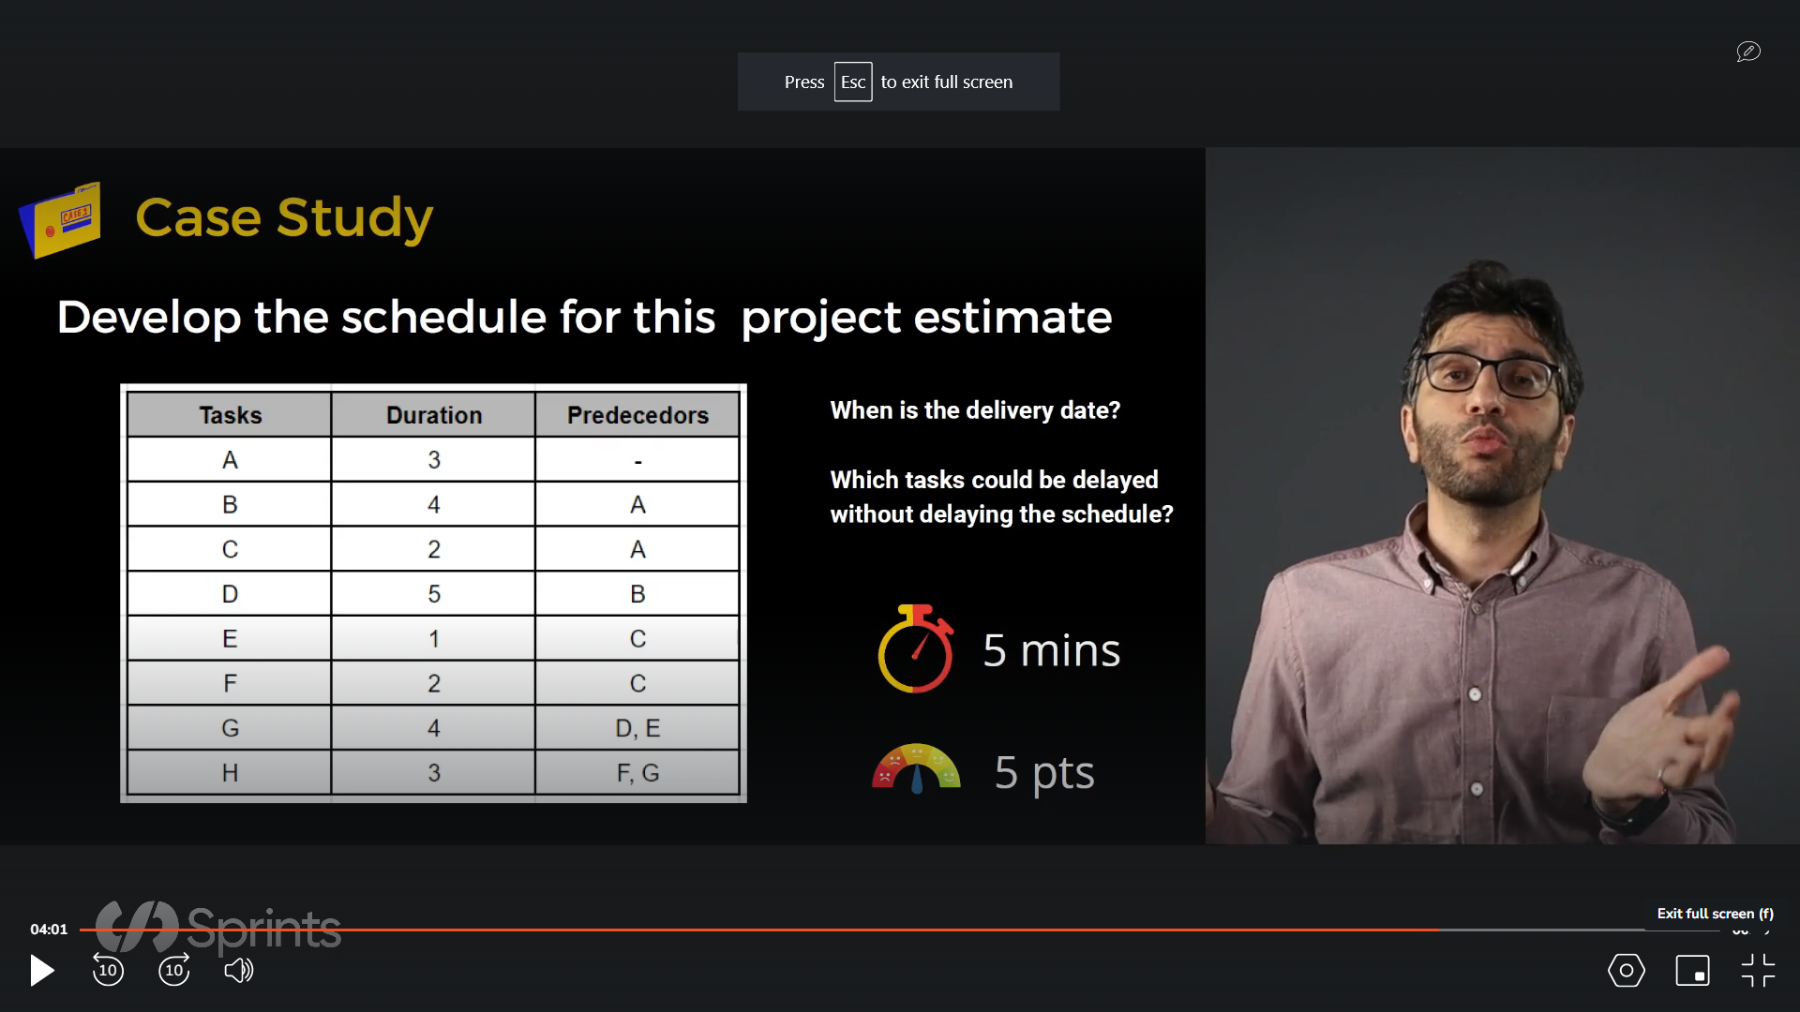

|  |  |  |  |  |  |  |  |  |  |  |  |  |  |  |  |  |  |  |  |
| --- | --- | --- | --- | --- | --- | --- | --- | --- | --- | --- | --- | --- | --- | --- | --- | --- | --- | --- | --- |
| A |  | | |  |  |  |  |  |  |  |  |  |  |  |  |  |  |  |  |
| B |  |  |  |  | | | |  |  |  |  |  |  |  |  |  |  |  |  |
| C |  |  |  |  | |  |  |  |  |  |  |  |  |  |  |  |  |  |  |
| D |  |  |  |  |  |  |  |  | | | | |  |  |  |  |  |  |  |
| E |  |  |  |  |  |  |  |  |  |  |  |  |  |  |  |  |  |  |  |
| F |  |  |  |  |  |  | |  |  |  |  |  |  |  |  |  |  |  |  |
| G |  |  |  |  |  |  |  |  |  |  |  |  |  | | | |  |  |  |
| H |  |  |  |  |  |  |  |  |  |  |  |  |  |  |  |  |  | | |
| DAYS | 1 | 2 | 3 | 4 | 5 | 6 | 7 | 8 | 9 | 10 | 11 | 12 | 13 | 14 | 15 | 16 | 17 | 18 | 19 |

Total number of days are 19 days

Tasks C, E, and F can be delayed

|  |  |  |
| --- | --- | --- |
| Day 1 | 3 | Day 3 |
| A | | |
| Day 1 | 0 | Day 3 |

|  |  |  |
| --- | --- | --- |
| Day 4 | 4 | Day 7 |
| B | | |
| Day 4 | 0 | Day 7 |

|  |  |  |
| --- | --- | --- |
| Day 4 | 2 | Day 5 |
| C | | |
| Day 10 | 6 | Day 11 |

|  |  |  |
| --- | --- | --- |
| Day 8 | 5 | Day 12 |
| D | | |
| Day 8 | 0 | Day 12 |

|  |  |  |
| --- | --- | --- |
| Day 6 | 1 | Day 6 |
| E | | |
| Day 12 | 6 | Day 12 |

|  |  |  |
| --- | --- | --- |
| Day 6 | 2 | Day 7 |
| F | | |
| Day 15 | 9 | Day 16 |

|  |  |  |
| --- | --- | --- |
| Day 13 | 4 | Day 16 |
| G | | |
| Day 13 | 0 | Day 16 |

|  |  |  |
| --- | --- | --- |
| Day 17 | 3 | Day 19 |
| H | | |
| Day 17 | 0 | Day 19 |